Question 1

1. 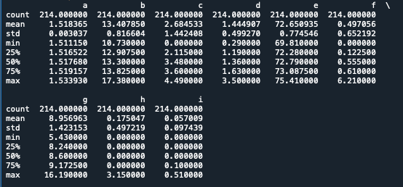Descriptive Analysis between the additives:

Figure 1: Descriptive Analysis between different formulations labelled: a, b,c,d,e,f,g,h,I,

* A picture containing square

  Description automatically generatedFrom Figure 1, we can see that the average level of additives is the highest among all.

Figure 2: Correlation map between different formulations

* The correlation map in Figure 2 demonstrates the level of how each formulations are linearly related to each other. A high correlation level indicates that there is a high possibility that the formulations are similar to each other. Notably, formulation ‘a’ and formulation ‘g’ has a very high possibility that they might be similar to each other due to the strong correlation within each other. The other formulations have very weak linear relationship within each other, which might indicate very small chance that the formulations happen to be similar to each other.
* To perform ANOVA, we have to ensure that the data in each category follows the normality assumption. Upon plotting the Normal QQ plot and the histogram, from Figure 4 the normality assumption fails at additive: c, f, h, i. Experimented and have found no suitable data transformation method to transform the data to achieve normality, use non-parametric method: Kruskal-Wallis rank sum test.

Figure 3: Normal QQ-plot(arranged alphabetically starting from top left)

Figure 4: Histogram of varying level of additives added

* We want to assess if the varying level of additives vary significantly. The following are the hypothesis statement:

H0 (Null hypothesis): The distribution of the different level of additives added are the same

H1 (Alternative hypothesis): The distribution of the different level of additives added are NOT the same

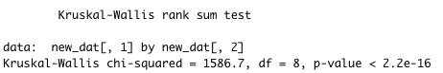

Figure 5: Output from Kruskal-Wallis rank sum test

From Figure 5 with a p-value less than 2.2 x ${10}^{16}$ we reject the null hypothesis and thus conclude that there are significant differences between the distribution of the different level of additives. Figure 3 could further supplement to this argument.

b)

Figure 6: Boxplot of different formulations

The different formulations labelled ‘a’, ‘b’, ‘d’, ‘e’ are normally distributed (with the highest concentration around the mean), with the rest of the other different formulations being highly skewed to the left or right (The tail values being the extreme or outliers). The outliers can also be seen in Figure 6.

c) The unsupervised learning method used was K-Means Clustering test.

Question 2

* Variables: Soil Moisture, Average Temperature, Minimum Temperature, Maximum Temperature, Precipitation, Working Days, Hectares Harvested, FFB Harvested (Hectares)

Given a research behind the physiology of oil palm trees, the three main external factors affecting the yield of FFB are identified as:

1. **Water**

* “Depending on the location, negative effects on fruit yield are observed when the annual water deficit is greater than 50–200 mm, with additional yield losses between 10 and 20 % for every 100 mm of water deficit from the threshold value inherent for each location (Woittiez et al., 2017). Therefore, water deficit is an important environmental stress factor that limits the production of oil palm fruits worldwide.”
* “Water supply is the main yield-limiting factor of oil palm crops. A water deficit affects virtually all aspects of metabolism and plant structure, while a water excess leads to waterlogging, an abiotic stress that affects crop production because of a reduction of oxygen in the soil”

1. Precipitation

* “Within the tropics, precipitation has been shown to have the strongest positive effect on palm species richness and future changes in rainfall patterns will likely alter palm distributions”

1. Temperature

* “Temperature increases have the potential to extend palm distributions to higher elevations and latitudes, but could negatively affect individual palm carbon balance”

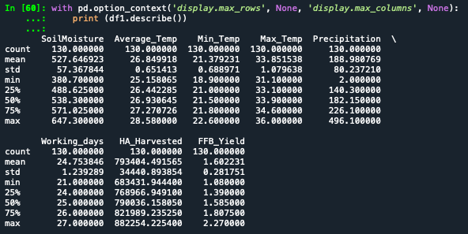

a)

Figure 1: Descriptive Analysis of the variables

According to Figure 3 below, an increase in precipitation has a positive linear trend to the FFB yield, which indicates that the higher the level of precipitation (in ml), the higher the FFB yield (in Tonnes/ Hectare).

FFB yield seems to not be affected by the average temperature (in Celcius degree), soil moisture (in Millilitres) as there is possibility of high and low yield within the same temperature or soil moisture except at the end of their respective axis where FFB yield seems to be low.

According to Figure 3 there is a positive linear trend between precipitation and soil moisture. We could assess the two variable’s relationship with the FFB yield demonstrated in Figure 2. According to Figure 3, high soil moisture indicates high precipitation level, but in Figure 2 this assumption doesn’t yield the best FFB yield.

From what is gathered, high precipitation level indicates that there will be a high amount of FFB yield, but soil moisture has to be kept at an optimum level (according to Figure 2, around the range 500 – 550ml), temperature is also needed to be kept at an optimum level (according to Figure 2, around 27 Celsius degree) in order to ensure FFB yield is maximised.

Figure 2: 3D Line Plot

Figure 3: Scatterplot and histogram with different variable combinations

Question 3

1. The probability of the word “data” occurring in each line: ﻿0.0533 (5.33%)
2. Chart, histogram

   Description automatically generated

Figure 1: Distribution of distinct words

According to Figure 1, there are not much analysis that could be done to the distribution of the distinct word counts as there are too many words that only appears once. Hence in Figure 2 below shows a better depiction of distinct words that carries more information throughout the passage:

Figure 2: Distribution of distinct words with word count greater than one.

From the bar plot above in Figure 2 excluding connectives such as ‘a’, ‘is’, ‘of’,’the’, the notable words are data, analytics, analysis.

1. The probability that the word “analytics” occurring after the word “data”: ﻿0.01881 (1.881%).